The topology of the IEEE-33 system is shown in Fig. 1. The peak loads of MG1, MG2 and MG3 are 1.2+j0.581MVA, 0.8+j0.387MVA and 1+j0.484MVA respectively. The ESS and DG paraments are shown in Table 1 and Table 2. The forecast data of loads and RDG’s output are shown in Fig. 2, with the assumption that the forecast data (per unit) of wind turbine (WT) and photovoltaic (PV) output are the same in each MG.

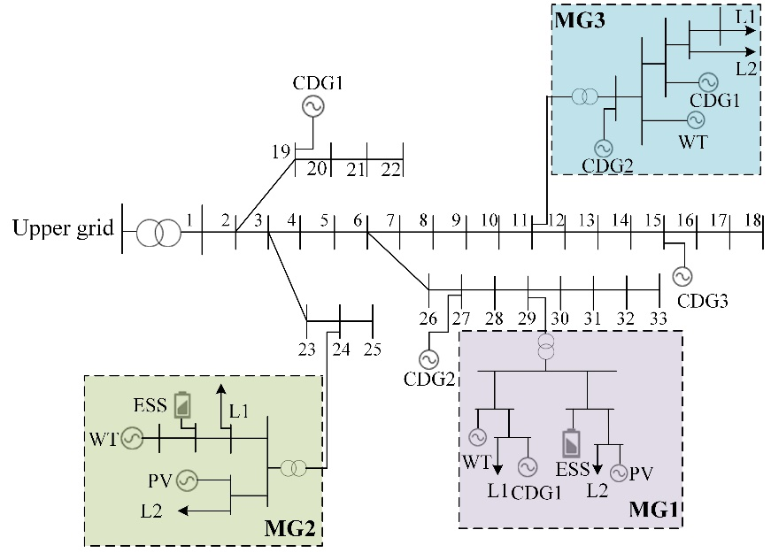

Fig. 1. Topology of an ADN with three MGs

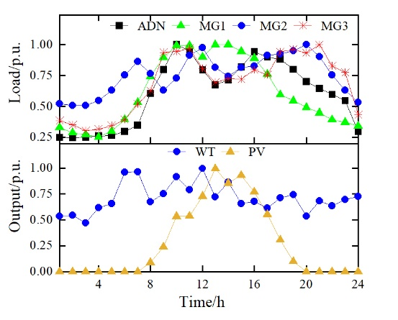

Fig. 2. The forecast load of ADN and MGs as well as the forecast output of WT and PV

Table 1. Parameters of ESSs

|  |  |  |  |  |
| --- | --- | --- | --- | --- |
| Region | /kW | /kWh | /kWh | *η*/% |
| MG1 | 200 | 1000 | 0 | 93 |
| MG2 | 250 | 1500 | 0 | 93 |

Table 2. Parameters of DGs

|  |  |  |  |
| --- | --- | --- | --- |
| Region | DG | *Pg*,min/kW | *Pg*,max/kW |
| ADN | CDG1 | 150 | 600 |
| CDG2 | 80 | 700 |
| CDG3 | 100 | 800 |
| MG1 | WT | 0 | 500 |
| PV | 0 | 400 |
| CDG1 | 50 | 400 |
| MG2 | PV | 0 | 500 |
| WT | 0 | 200 |
| MG3 | WT | 0 | 400 |
| CDG1 | 30 | 300 |
| CDG2 | 0 | 400 |